Chemistry: 2. Solutions
Please remember to photocopy 4 pages onto one sheet by going A3→A4 and using back to back on the photocopier

Syllabus
OC15 Investigate the solubility of a variety of substances in water and the effect of temperature on solubility

OC16 Examine the difference between a dilute, concentrated and saturated solution

OC17 Grow crystals using alum or copper sulfate

Student Notes
A solution is formed when a solid dissolves in a liquid

The solid is referred to as the solute.
The liquid is referred to as the solvent.

A dilute solution is one where there is a lot of solvent and only a little solute

A concentrated solution is one where there is a lot of solute and only a little solvent

A solution can be made more concentrated by adding more of the solute or evaporating off some solvent

A saturated solution is one where no more solute will dissolve in the solvent

Experiment: To investigate the solubility of a variety of substances in water and the effect of temperature on solubility
Example; table salt
Determine the maximum mass, in grams, of salt that will dissolve in 100 g of water at various temperatures.
Plot a graph of the results (see exam questions)

Crystals
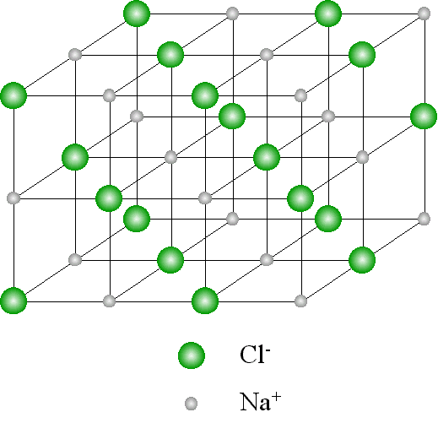
Some solids are always found in the form of a crystal.
Crystalline solids have definite shapes because the atoms in the crystal are in a regular pattern.
Examples include sugar and salt diamonds and ice.

Salt is composed of two different types of atom, sodium (symbol Na) and chlorine (symbol Cl), arranged in an orderly pattern as shown.

Other solids are said to be non-crystalline.
Example: flour

Mandatory Experiment: To grow crystals using copper sulphate
Procedure:
Keep adding copper sulphate powder to hot water until no more will dissolve.
Allow to cool slowly.
Result:
Crystals begin to grow
Exam Questions
- [2007]
Distinguish between a concentrated and a dilute solution.

- [2011]
The diagram shows three solutions of copper sulphate.
- Starting with a dilute solution state how to make it more concentrated.
- How do you know when a saturated solution has been produced?

- [2007]
  - Name a substance, other than water, that forms crystals.
  - Give one difference between crystalline and non-crystalline solids.

- [2010 OL]
The growth of crystals can be investigated using either alum or copper sulfate.
The experimental procedure is similar in each case.
When you carried out this investigation the first thing you had to do was to make up a hot saturated solution of either alum or copper sulfate.
- Name the solvent in which the alum or copper sulfate was dissolved.
- How was the solvent heated?
- What needed to be done to the hot saturated solution so that crystals formed?
- Other than the piece of equipment used to heat the solvent name one other piece of equipment used in this experiment.

- [2006 OL]
Describe how you could carry out an experiment to grow crystals using alum or copper sulphate.
Include a diagram of any equipment used.

- [2009 OL]
In a school laboratory, a student investigated the solubility of a salt in water.
Temperature  °C | 20 | 30 | 40 | 70 | 90
Solubility  g per 100 cm³ of water | 10 | 20 | 30 | 60 | 80
The amount of salt which dissolved in water at different temperatures was measured. The data collected is presented in the table below.

- Use this data to draw a graph of solubility (y-axis) against temperature (x-axis) using the grid provided below.
- Use the graph to estimate the solubility at 60 °C.
- What can you conclude about the solubility of the salt in water from the graph?
- [2007]
A pupil investigated the effect of temperature on the solubility of the salt ammonium chloride in water. She determined the maximum mass, in grams, of the salt that would dissolve in 100 g of water at various temperatures.
The data from this experiment are given in the table.
Solubility (g / 100 g water) | 29 | 37 | 46 | 55 | 66 | 77
Temperature (⁰C) | 0 | 20 | 40 | 60 | 80 | 100

- Plot a graph of solubility against temperature.
- Use the graph to estimate the solubility of ammonium chloride at 70 ºC.
- What conclusion about the solubility of ammonium chloride can be drawn from analysis of the graph?

- [2010]
A pupil used the apparatus shown in the diagram to quantitatively investigate the effect of temperature on the solubility of copper sulfate crystals in water.
100 g of water in the conical flask was brought to the required temperature using the water bath.
Copper sulfate crystals were added to the water until no more would dissolve. The mass of the copper sulphate crystals that dissolved was noted.

The data was recorded and is given the table.

Temperature (⁰C) | 0 | 20 | 40 | 60 | 80 | 100
Mass of copper sulphate crystals dissolved (g/ 100 g) | 14 | 21 | 29 | 40 | 55 | 75

- Draw a graph of mass of copper sulfate crystals dissolved (solubility) against temperature in the grid below. A smooth curve through the plotted points is required.
- Use your graph to estimate the solubility of copper sulfate crystals at 10 ⁰C.
- Describe, using an appropriate labelled diagram how to grow and collect crystals of copper sulfate from the solution produced at 100 ⁰C.
- [2008]
The limit of solubility (maximum solubility) of oxygen gas (O₂) in water was measured, in mg of oxygen per 100 g of water, at a number of different temperatures. These measurements are given in the table.
Solubility (mg / 100 g water) | 7.0 | 4.3 | 3.0 | 2.3 | 1.4 | 0.8 | 0.0
Temperature (⁰C) | 0 | 20 | 40 | 60 | 80 | 90 | 100

  - Draw a graph of solubility (y-axis) against temperature (x-axis) in the grid provided below.
- Use the graph to estimate the solubility of oxygen at 30 °C.
- What effect has temperature on the solubility of oxygen in water?
- Global warming has many implications. What implication, which could be inferred (concluded) from the information in the graph, might global warming have for animals that live in water e.g. fish?

- [2012]
An experiment was performed to investigate the effect of temperature on the solubility of carbon dioxide in water.
The data obtained from this experiment is given in the table below.

Solubility of CO₂ (grams of CO₂ per kg of water) | 3.4 | 2.5 | 1.7 | 1.4 | 1.0 | 0.8 | 0.6
Temperature (⁰C) | 0 | 10 | 20 | 30 | 40 | 50 | 60

- Draw a graph of solubility against temperature in the grid below using the data from the table.
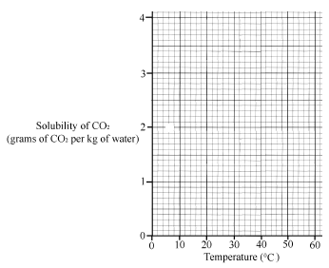
A smooth curve is required.

- Usually the solubility of a solid increases with increasing temperature.
The solubility of a gas decreases as the temperature increases. Suggest a reason why this decrease happens.
- From the graph estimate the temperature at which the solubility of CO₂ is 2 g per kg of water.

Exam Solutions
- Concentrated: a lot of solute in a small amount of solvent (water).
Dilute: a small amount of solute in a lot of solvent (water).

- Dissolve (add) copper sulfate (solute)/ evaporate off some of the solvent
- No more copper sulfate (solute) will dissolve

- Alum/ copper sulphate/ salt/ sugar/ silicon/ iodine/ diamond…
- Crystalline solids have definite (geometric) shapes/ particles in crystals are in regular (geometric) order/ texture e.g. salt and sugar ‘feel’ different to flour/ crystals affect light/ shiny / sparkle…
- Water
- Bunsen burner / hotplate
- Allow to cool / seeding / scratching beaker with glass rod
- Beaker
- Dissolve solute in hot water
Keep adding (add more) until no more dissolves.
Allow to cool slowly
After a number of hours crystals begin to form.

- Plot the points correctly and join plotted points in the form one straight line.
- 50
- Solubility increases with temperature

- See (top) graph [straight line going in between the points].
- 61 (any number between 58 to 64 is acceptable)
- Solubility is proportional to temperature/ solubility increases with temperature

- See second graph
- 15-18
- Heat a solution of copper sulphate and allow to cool
Crystals form
Filter/ evaporate
Suitable diagram

- See graph.
- 3.6
- Solubility decreases as temperature increases
- Less oxygen for respiration (breathing)/ fish (animals) die

- See graph
- Temperature increases the motion of gases/ allow them to escape/ weak attractive forces / gases expand/ gases rise/ gases less dense/ bubbles form/ gas molecules have more energy…
- Estimate 16 ⁰C +/- 2 ⁰C
Other test questions
- Name a substance, other than water, that forms crystals.

- Give one difference between crystalline and non-crystalline solids.

- Give two methods that a student could use to make dilute copper sulphate solution more concentrated when making copper sulphate crystals.

